**Pizza Sales Project**

**--Created database—**

create database pizza_sales

use pizza_sales

select * from pizza

--**Checking for missing values—**

select * from pizza

where pizza_id is null or order_id is null or pizza_name is null or pizza_name_id is null or order_time is null or order_date is null

**--What days do we tend to be busiest? --**

select datename (weekday, order_date) days, count (distinct order_id) total_order, (count (distinct order_id)/count (distinct order_date)) avg_order_daily from pizza

group by datename (weekday, order_date)

order by (count (distinct order_id)/count (distinct order_date)) desc

**--What times do we tend to be busiest? --**

select concat (format ((datepart (hour, order_time) +11) %12 + 1,'00'),

' ', iif (datepart (hour, order_time) <12,'AM','PM')) hours, count (distinct order_id) total_order from pizza

group by concat (format ((datepart (hour, order_time) +11) %12 + 1,'00'),

' ', iif (datepart (hour, order_time) <12,'AM','PM'))

order by count (distinct order_id) desc

**--Total Revenue (KPI)—**

select round(sum(total_price),0) Total_amount from pizza

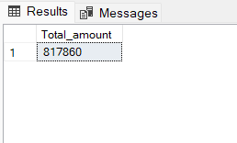

**--Average Order Value (KPI)--**

select round(sum(total_price) / count (distinct order_id),0) avg_order_value from pizza

**--Total Pizzas Sold(KPI)—**

select count(quantity) Total_pizza_sold from pizza

**--Daily Trend for Total Orders--**

select day(order_date) days, count(order_id) no_of_orders from pizza

group by day(order_date)

order by day(order_date)

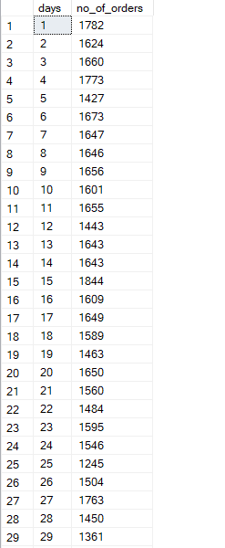

**--Total Orders(KPI)--**

select count (distinct order_id) from pizza

**--Average Pizzas Per Order (KPI)—**

select sum(total_price)/count(pizza_id) from pizza

**--Monthly Trend for Orders--**

select datename (month, order_date) Months, count (distinct order_id) Total_orders from pizza

group by datename (month, order_date)

order by count (distinct order_id) desc

**--Percentage of Sales by Pizza Category—**

select pizza_category, round(sum(total_price),0) total_price, round(sum(total_price) *100/(select(sum(total_price)) from pizza),2) percentages from pizza

group by pizza_category

order by round(sum(total_price) *100/(select(sum(total_price)) from pizza),2) desc

**--Best-selling pizza--**

select top 3 pizza_name, sum(quantity) Pizza_sold from pizza

group by pizza_name

order by sum (quantity) desc

**--Worst selling pizza--**

select top 3 pizza_name, sum(quantity) Pizza_sold from pizza

group by pizza_name

order by sum(quantity)

**--Percentage of Sales by pizza size--**

select pizza_size,

round(sum(total_price),0), round(sum(total_price) *100/(select(sum(total_price)) from pizza),0) percentage_of_sales from pizza

group by pizza_size

order by round(sum(total_price) * 100/(select(sum(total_price)) from pizza),0) desc

**-- Total pizza sold by pizza category--**

select pizza_category, sum(quantity) quantity from pizza

group by pizza_category

order by sum(quantity) desc

**-- Total orders by pizza category--**

select pizza_category, count(distinct order_id) total_order from pizza

group by pizza_category

order by count (distinct order_id) desc

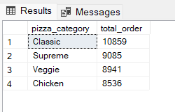

**-- Top 5 pizzas by quantity--**

select top 5 pizza_name, sum(quantity) total_quantity from pizza

group by pizza_name

order by 2 desc

**-- Top 5 pizzas by revenue--**

select top 5 pizza_name, sum(total_price) total_price from pizza

group by pizza_name

order by 2 desc

**-- Top 5 pizzas by order--**

select top 5 pizza_name, count(order_id) total_orders from pizza

group by pizza_name

order by 2 desc

**-- bottom 5 pizzas by quantity--**

select top 5 pizza_name, sum(quantity) total_quantity from pizza

group by pizza_name

order by 2

**-- bottom 5 pizzas by revenue--**

select top 5 pizza_name, round(sum(total_price),0) total_price from pizza

group by pizza_name

order by 2

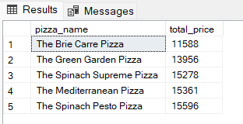

**-- bottom 5 pizzas by order--**

select top 5 pizza_name, count(order_id) total_order from pizza

group by pizza_name

order by 2

